Data Visualization: Assignment 4

Student 1: Sofya Aksenyuk, 150284

Student 2: Uladzimir Ivashka, 150281

# Design

# Dashboard name and purpose

Name: Covid Tracker

Purpose: Track Covid-19 statistics all over the world

# Tasks solved using the dashboard

1. – make the dashboard useful and convenient for a user
2. – try to show all of the most important data from the dataset according to the selected topic
3. – make data values understandable for a user (a potential user should be able to get if a value of, e.g., total covid-infected cases is proportionally large or not in comparison with other countries and their size)
4. – get better understanding of R dashboards structures and syntaxis

# Sketches

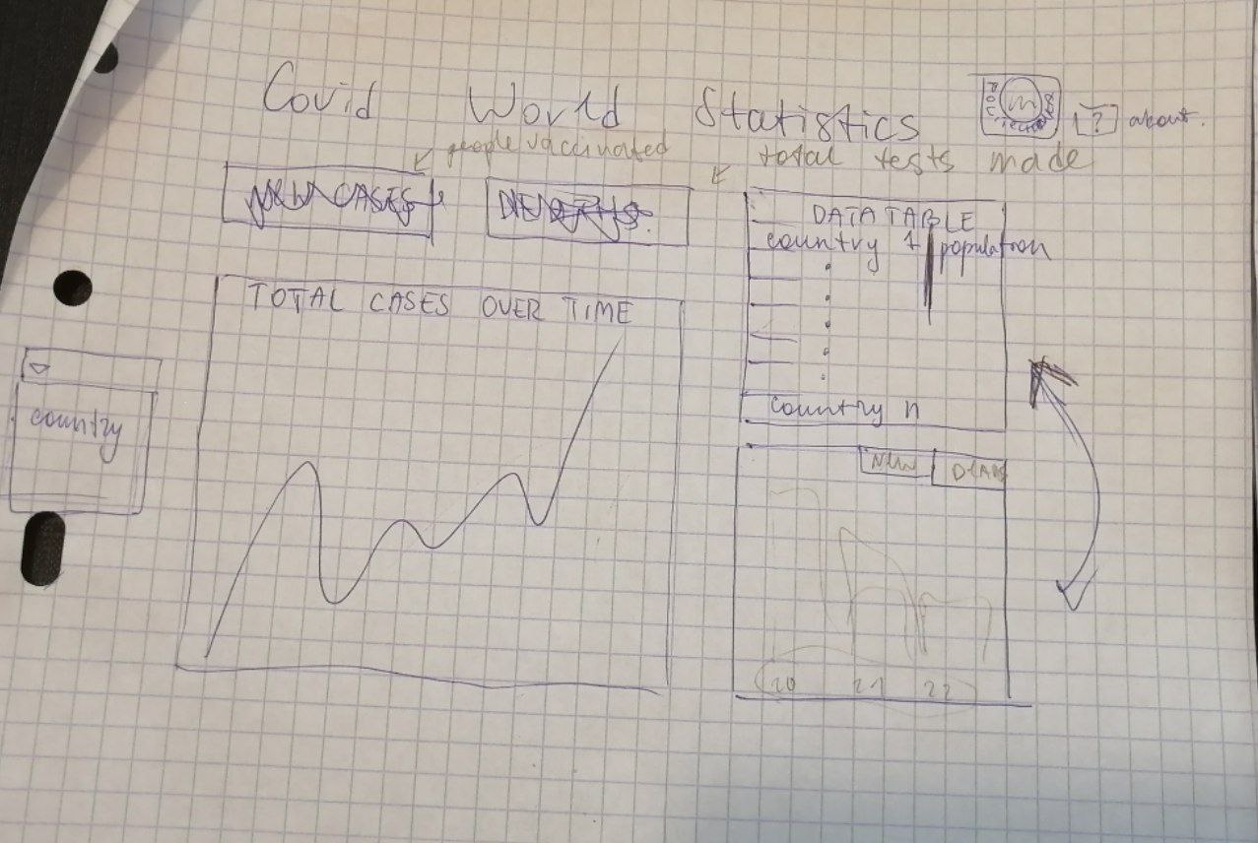

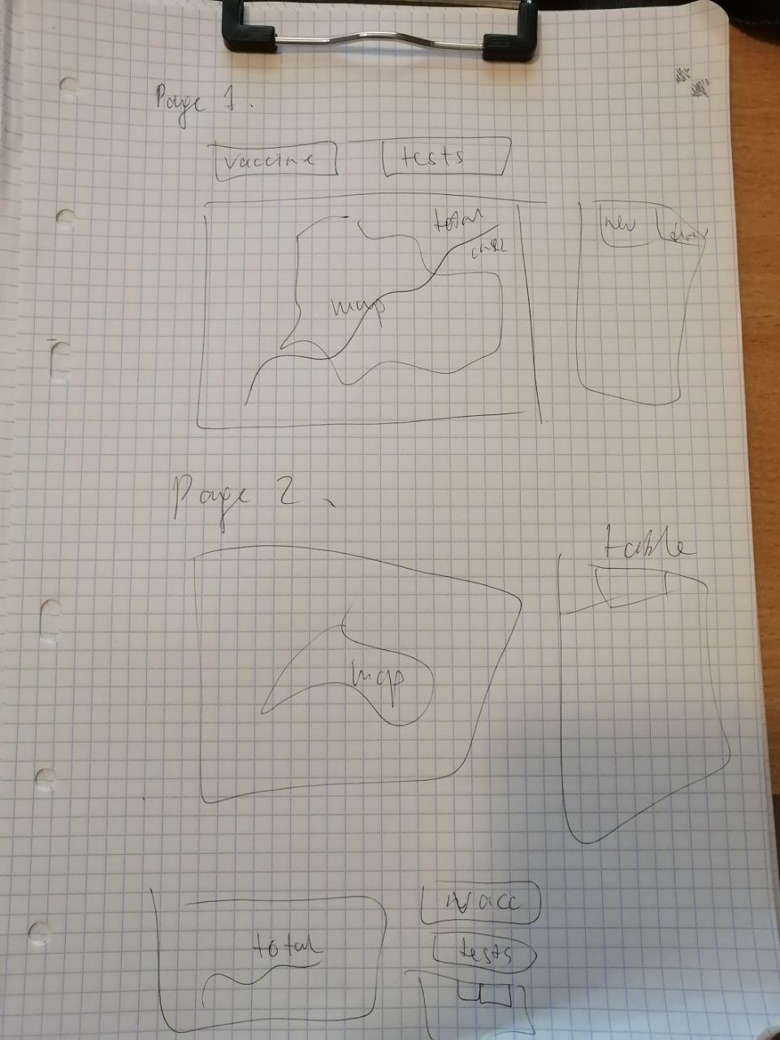

Implementation

# Screenshots

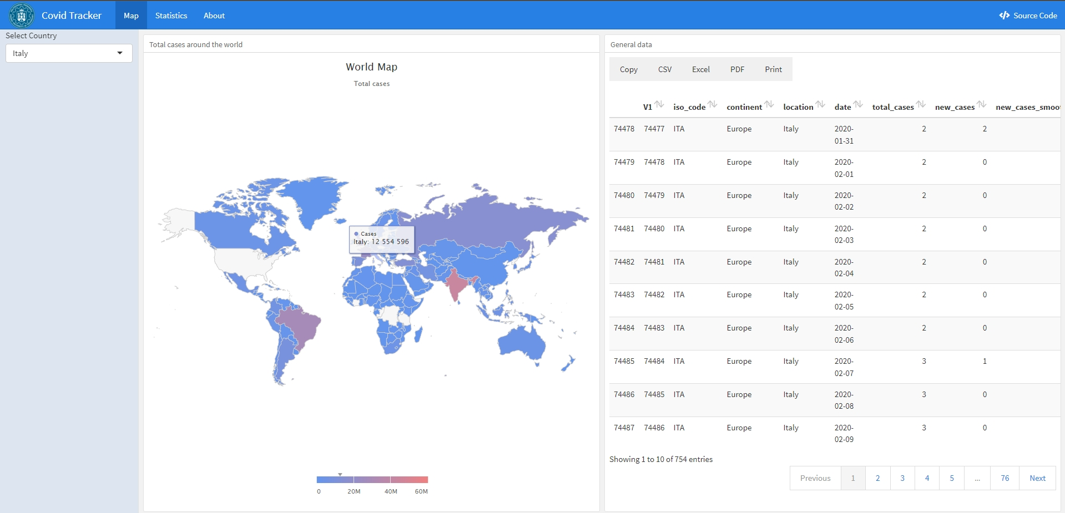

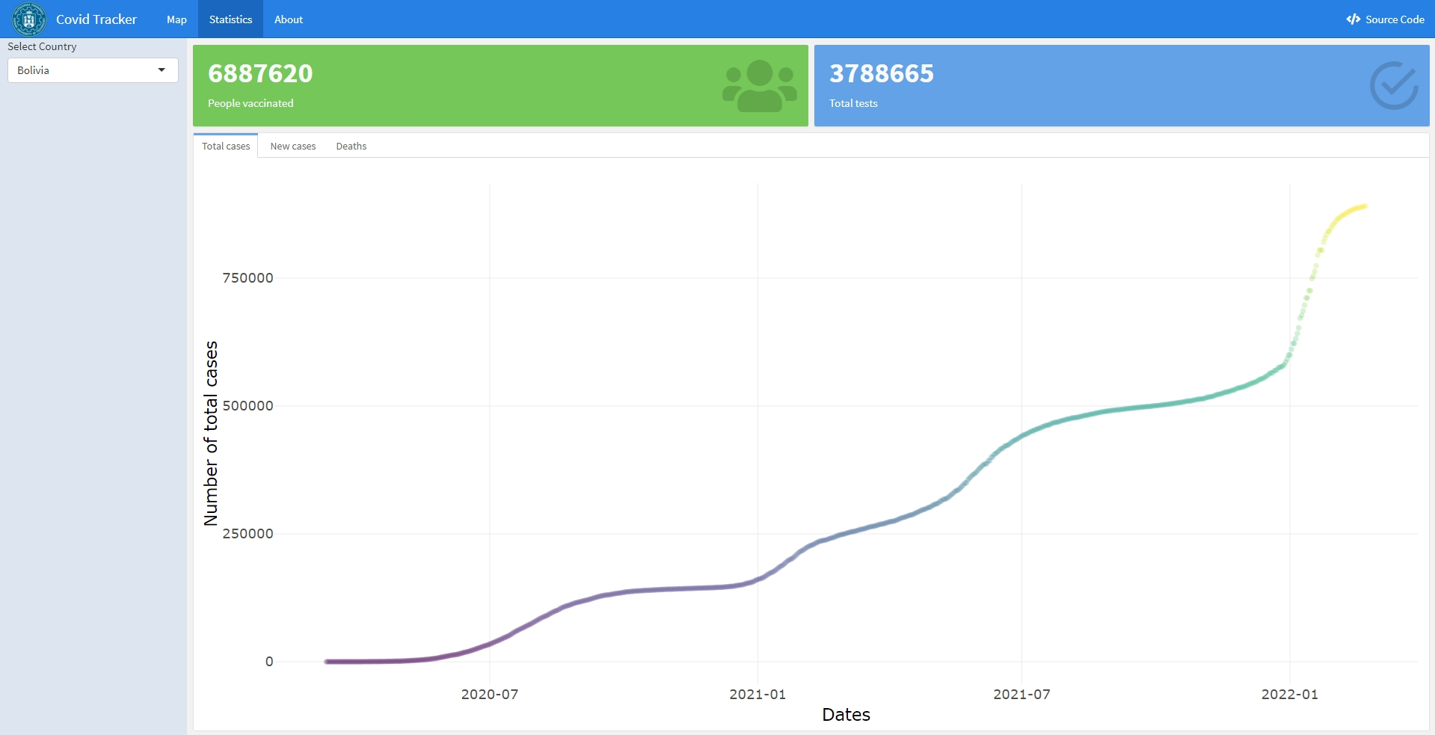

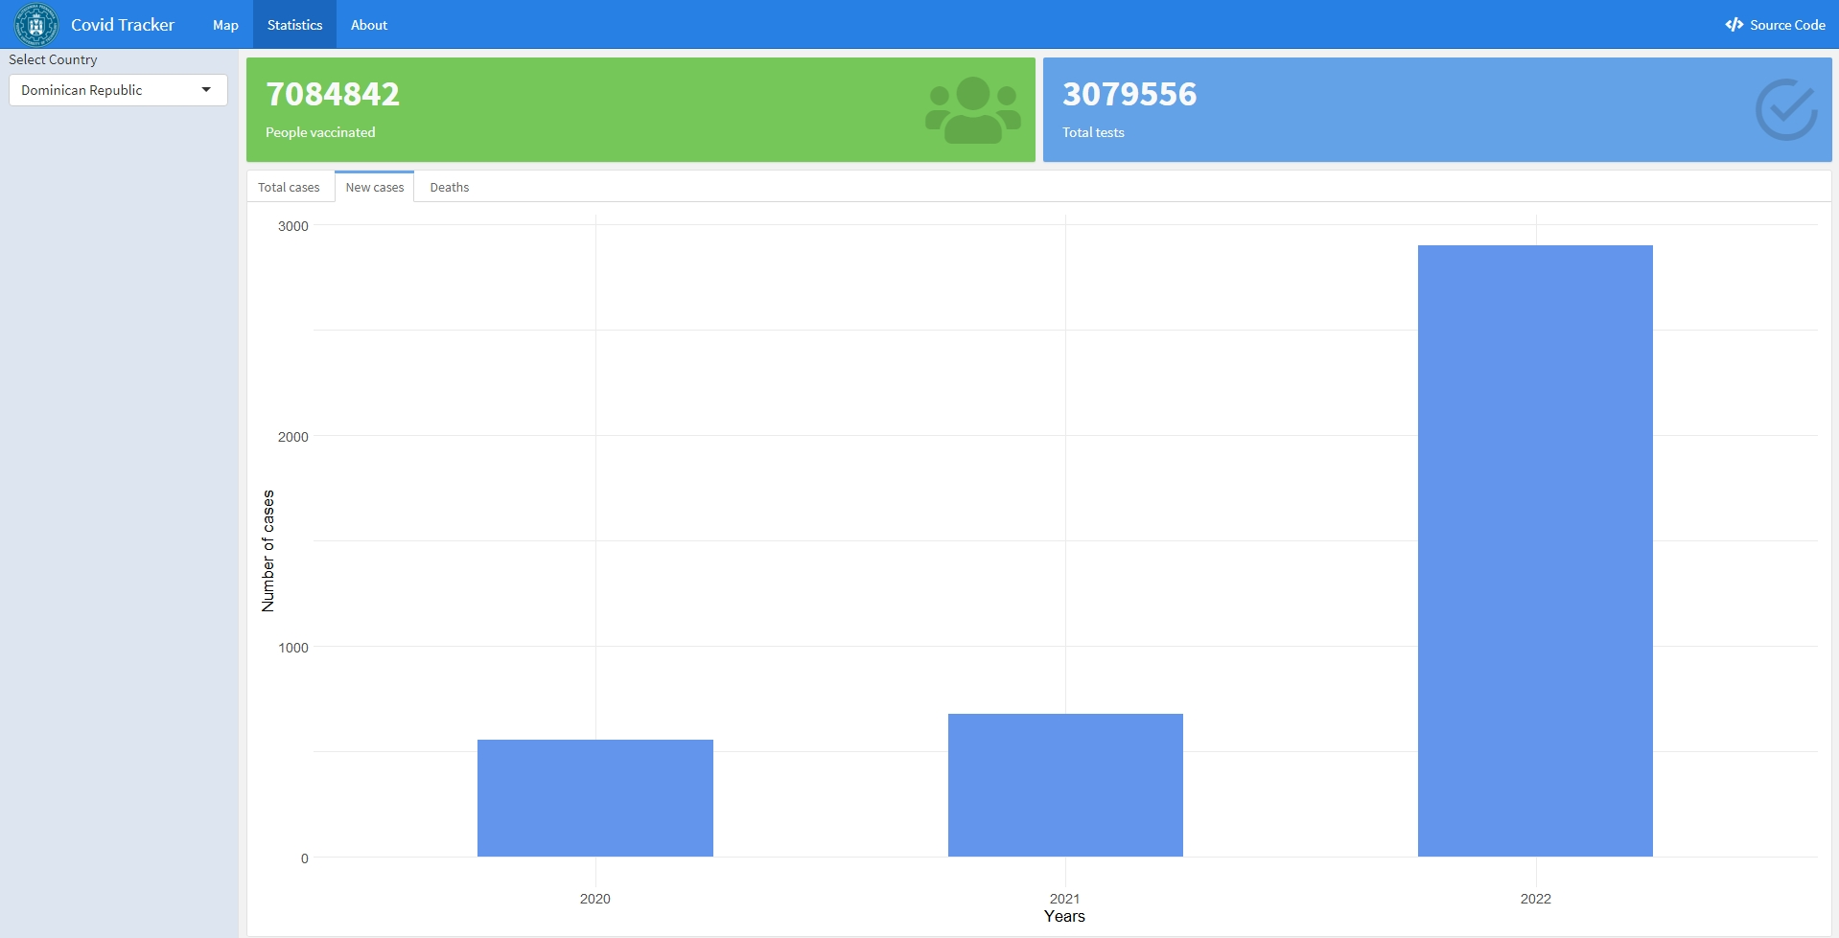

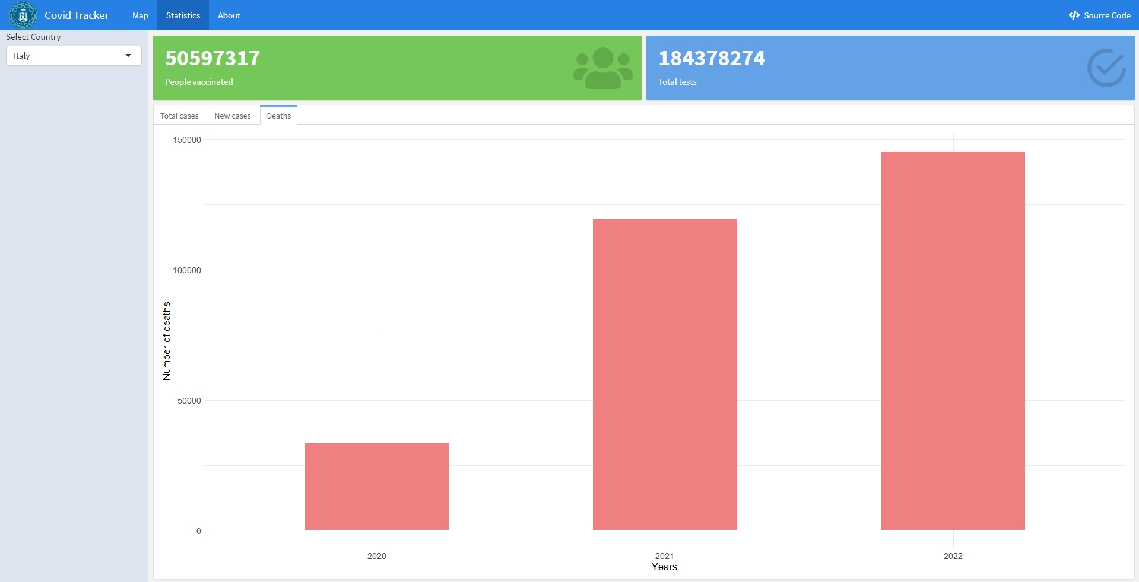

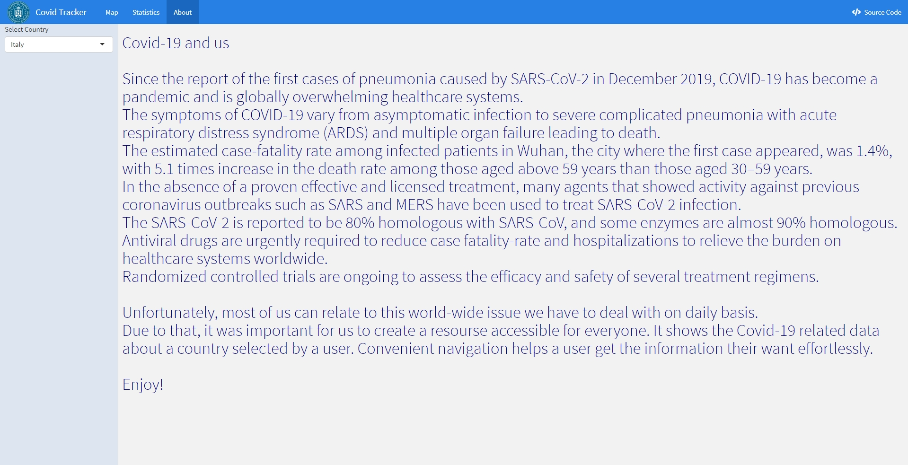

# Github

https://github.com/allsuitablenamesarealreadytaken/Covid-Tracker-dashboard

# Link to live demo

https://saxonya.shinyapps.io/Covid-Tracker/#section-map